**Ideation Phase**

**Brainstorm & Idea Prioritization Template**

|  |  |
| --- | --- |
| Date | 19 September 2022 |
| Team ID | PNT2022TMID29760 |
| Project Name | Project - Smart Fashion Recommender  Application |
| Maximum Marks | 4 Marks |

**Brainstorm & Idea Prioritization:**

**Brainstorm, Idea Listing and Grouping:**

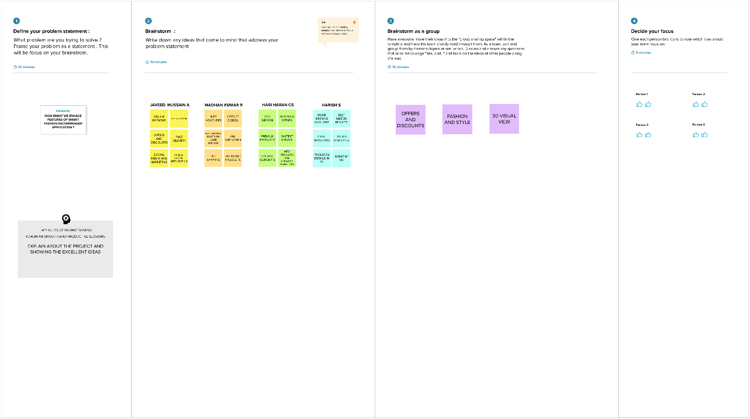

**Idea Prioritization:**

